Year 1/2 Long Term and Skills Progression Overview B
Persuade Inform Entertain Discuss
Autumn 1 | Autumn 2 | Spring 1 | Spring 2 | Summer 1 | Summer 2
Learning Journey 1 | Learning Journey 1 | Learning Journey 1 | Learning Journey 1 | Learning Journey 1 | Learning Journey 1
Text: Paddington Bear  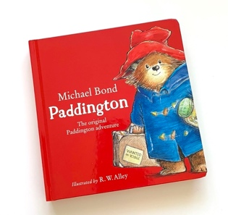  Final outcome: postcard  Outcome 2  Fact writing about Peru | Text: The Owl and The Pussy Cat  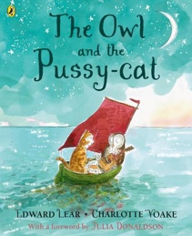  SOA: postcard from the Owl/Pussy Cat  Final outcome:  narrative | Text: We Are Water Protectors  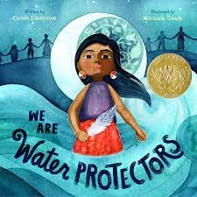  Final outcome:  Persuasive environmental campaign | Text: Look Up  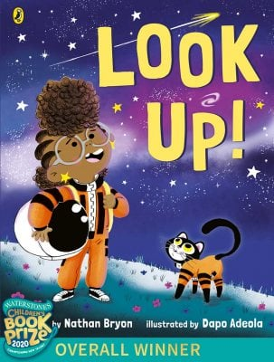  SOA  Setting description of a night’s sky  Final outcome: diary | Text: The Lighthouse Keep’s Lunch  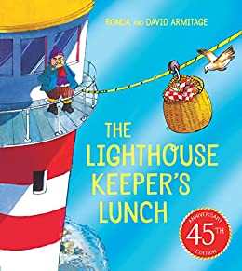  SOA  May Day Writing about rea events  Final outcome  Fact file about the seaside  Second outcome: instructions (link with DT) | Text: The Storm Whale  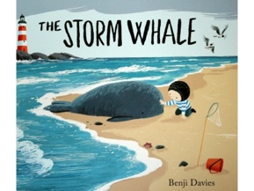  Final outcome: letter to find out information
Writing Skills  - beginning to punctuate sentences using a capital letter and a full stop, question mark or exclamation mark (Y1)  - using a capital letter for names of people, places, the days of the week, and the personal pronoun ‘I’ (Y1)  - expanded noun phrases (Y2)  - Reading Skills ask relevant questions to extend their understanding and knowledge (Y1)  - inferences on the basis of what is being said and done | Writing Skills  Learning to spell more words with contracted forms  - Add suffixes to spell longer words, including –ment, –ness, –ful, –less, –ly  - Capital letters for names and for the personal pronoun I [Year 1]  - Subordination (using when, if, that, because)  - Correct choice and consistent use of present tense and past tense throughout writing  - Commas to separate items in a list  Reading skills  - Listening to, discussing and expressing views about a wide range of contemporary and classic poetry, stories and non-fiction at a level beyond that at which they can read independently  • Recognising simple recurring literary language in stories and poetry  • Discussing and clarifying the meanings of words, linking new meanings to known vocabulary | Writing Skills  - Add suffixes to spell longer words, including –ment, –ness, –ful, –less, –ly  - Subordination (using when, if, that, because)  - sequence sentences to form simple narratives  - How the grammatical patterns in a sentence indicate its function as a statement, question,  exclamation or command  - Use of capital letters, full stops, question marks and exclamation marks to demarcate  sentences  Reading Skills  - Listening to, discussing and expressing views about a wide range of contemporary and classic poetry, stories and non-fiction at a level beyond that at which they can read independently  - Answering and asking questions | Writing Skills  - Correct choice and consistent use of present tense and past tense throughout writing  Reading Skills  - Listening to, discussing and expressing views about a wide range of contemporary and classic poetry, stories and non-fiction at a level beyond that at which they can read independently  - Answering and asking questions  - Make predictions about a story | Writing Skills  - To use conjunctions  - To identify and use verbs  - To use the suffix -ly (Y2)  - To sequence sentences  Reading Skills  - To make inferences about what is said and done  - To make links with other stories | Writing Skills  - Use simple word choice that helps to convey information and ideas, e.g. story or topic related vocabulary  - Begin to punctuate sentences using a question mark  - Use simple noun phrases (adjective + noun)  - Write a sequence of sentences  - Reread what I have written to check it makes sense  Reading skills  Recall the main points of a narrative in the correct sequence  Ask questions and express opinions about main events and characters in stories
Learning Journey 2 | Learning Journey 2 | Learning Journey 2 | Learning Journey 2
 | 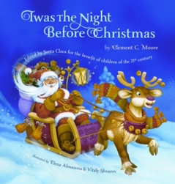  Text: Twas the Night Before Christmas  Final outcome: a diary  Writing Skills  - To write in the past tense  - Use conjunctions and (y1) because, but, if (Y2)  Reading Skills  - Listening to, discussing and expressing views about a wide range of contemporary and classic poetry, stories and non-fiction at a level beyond that at which they can read independently  • Recognising simple recurring literary language in stories and poetry  • Discussing and clarifying the meanings of words, linking new meanings to known vocabulary  - answering and asking questions  - making links between texts | Text: The Dragon Machine  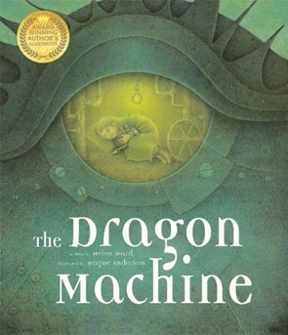  Final outcome: narrative  Writing Skills  Using the prefix un–  - Formation of nouns using suffixes such as –ness, –er and by compounding [for example, whiteboard, superman]  - Expanded noun phrases for description and specification [for example, the blue butterfly, plain  flour, the man in the moon]  Reading Skills  Predicting what might happen on the basis of what has been read so far  • Explaining and discuss their understanding of books, poems and other material, both those  that they listen to and those that they read for themselves | Text: Astro Girl  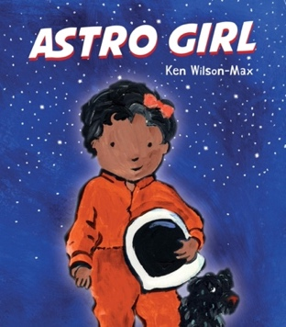  Final outcome: fact file  Writing Skills  Joining words and joining clauses using and sequencing sentences to form short narratives  • Subordination (using when, if, that, because) and co-ordination (using or, and, but)  • How the grammatical patterns in a sentence indicate its function as a statement, question,  exclamation or command  • Use of capital letters, full stops, question marks and exclamation marks to demarcate  Sentences  Reading skills  Predicting what might happen on the basis of what has been read so far  • Being introduced to non-fiction books that are structured in different ways (Y2)  • Drawing on what they already know or on background information and vocabulary provided  by the teacher (Y2)
Ongoing Reading Skills
ask relevant questions to extend their understanding and knowledge (Y1)
articulate and justify answers, arguments and opinions (Y1)
being encouraged to link what they read or hear read to their own experiences(Y1)
making inferences on the basis of what is being said and done (Y1)
listening to, discussing and expressing views about a wide range of, stories (Y2)
discussing the sequence of events in books and how items of information are related (Y2)
answering and asking questions (Y2)
Ongoing Writing Skills
saying out loud what they are going to write about (Y1)
sequencing sentences to form short narratives (Y1)
re-reading what they have written to check that it makes sense (Y1)
writing narratives about personal experiences and those of others (real and fictional) (Y2)
planning or saying out loud what they are going to write about (Y2)
evaluating their writing with the teacher and other pupils (Y2)

